**6-08-24 Java Lab Codes**

Program 1:

class Student

{

    public String name;

    Student(String name)

    {

        this.name=name;

    }

    public String toString()

    {

        return name;

    }

}

public class Ex3

{

    public static void main(String[] args)

    {

        Student[] myStudents = new Student[]{new Student("Dharma"), new Student("sanvi"), new Student("Rupa"), new Student("Ajay")};

        for(Student m:myStudents)

        {

            System.out.println(m);

        }

    }

}

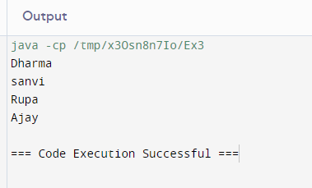

Program 2:

public class Ex3

{

    public static void main(String[] args)

    {

        int[] arr = new int[4];

        arr[0]=10;

        arr[1]=20;

        arr[2]=30;

        arr[3]=40;

        System.out.println("trying to access element outside the size of array");

        System.out.println(arr[5]);

    }

}

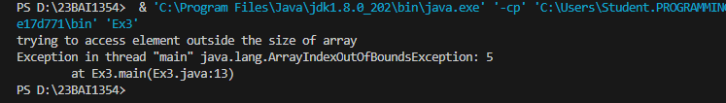

Program 3:

public class Ex3

{

    public static void main(String[] args)

    {

        int [][] arr = new int[10][20];

        arr[0][0]=1;

        System.out.println("arr[0][0] "+arr[0][0]);

    }

}

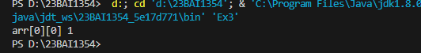

Program 4:

public class Ex3

{

    public static void main(String[] args)

    {

        int [][][] arr = new int[10][20][30];

        arr[0][0][0]=1;

        System.out.println("arr[0][0][0]= "+arr[0][0][0]);

    }

}

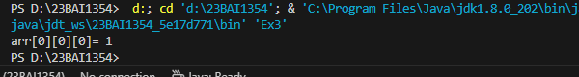

Program 5:

public class Ex3

{

    public static void main(String[] args)

    {

        int arr[]={3,1,2,5,4};

        sum(arr);

    }

    public static void sum(int[] arr)

    {

        int summ=0;

        int i=0;

        for(i;i<arr.length;i++)

        int summ=0;

        {

            summ+=arr[i];

        }

        System.out.println("sum of array values: "+summ);

    }

} /*error: Syntax error on token "i", ++ expected after this token

Syntax error, insert ". class" to complete Expression

Syntax error, insert "AssignmentOperator Expression" to complete Assignment

Syntax error, insert ";" to complete Statement

The left-hand side of an assignment must be a variable

at Ex3.sum(Ex3.java:12)

at Ex3.main(Ex3.java:6) */

Program 6:

public class Ex3

{

    public static void main(String[] args)

    {

        int arr[]=m1();

        for(int i=0;i<arr.length;i++)

            System.out.println(arr[i]+" ");

    }

    public static int[] m1()

    {

        return new int[] {1,2,3};

    }

}

Output:

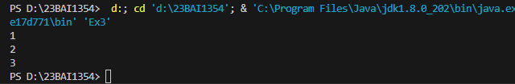

Program 7:

public class Ex3

{

    public static void main(String args[])

    {

        int intArray[]= new int[3];

        byte byteArray[] = new byte[3];

        short shortsArray[] = new short[3];

        String[] strArray = new String[3]; //array of strings

        System.out.println(intArray.getClass());

        System.out.println(intArray.getClass().getSuperclass());

        System.out.println(byteArray.getClass());

        System.out.println(shortsArray.getClass());

        System.out.println(strArray.getClass());

    }

}

Output:

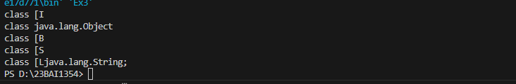

Program 8:

public class Ex3

{

    public static void main(String args[])

    {

        int intArray[]= {1,2,3};

        int cloneArray[] = intArray.clone();

        //will print false as deep copy is created

        //for 1d array

        System.out.println(intArray==cloneArray);

for(int i=0;i<cloneArray.length;i++)

        {

            System.out.println(cloneArray[i]+" ");

        }

    }

}

Output:

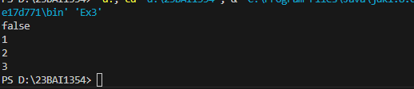

Program 9:

public class Ex3

{

    public static void main(String args[])

    {

        int intArray[][]= {{1,2,3},{4,5}};

        int cloneArray[][] = intArray.clone();

        System.out.println(intArray==cloneArray);

        System.out.println(intArray[0]==cloneArray[0]);

        System.out.println(intArray[1]==cloneArray[1]);

    }

}

Output:

